25 Av
Aug. 14-15, 2020
Re’eh

Congregation Shaya Ahavat Torah
Parsippany, NJ 973-335-3636
www.parsippanyshul.org

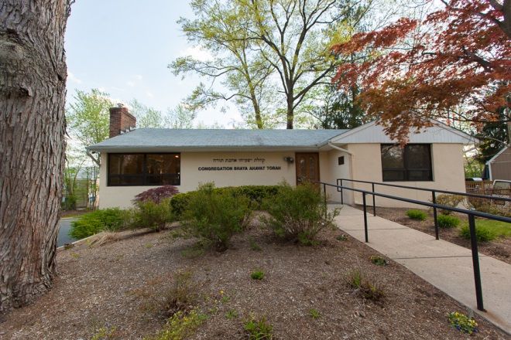

Shalom D. Lubin, Rabbi Naomi G. Rotter, President
This Shabbos – Re’eh
Candle Lighting – 7:39 PM Shabbos Mincha –7:20 PM
Friday Mincha – 7:40 PM Shabbos Ends - 8:39 PM
This Shabbos the Challah is sponsored by Michelle and David Horowitz in honor of their 10th anniversary.
Looking Ahead Tuesday Aug 18 - 8:00 PM – Gemora class via conference call with Rabbi Lubin. Simple 2-step instructions: 1. Dial: (712) 775-7200 2. Enter Access Code: 233971, then hit the # key. You will then be on the call.
Thursday– Torah portion of the week via conference call with Rabbi Lubin is on break during August.
Challah Sponsorships - In place of our traditional Shabbos Kiddush which continues on hold as a health precaution, we would like to make Challah sponsorship a weekly tradition. We encourage you to consider sponsoring a Challah distribution over the next few weeks to commemorate a lifecycle milestone! Weekly Sponsorships are $180, Please contact Naomi to reserve a week and for more information. Next week is open -- August 21-22 (Shoftim)!

Upcoming Shabbos Challah Sponsorship: August 29 – Ki Seitzei: Connie Pallas & Barry Levitt - in honor of the yahrzeit of Barry's Mother, Hinde bat Naftoli (Hilda Levitt) and Connie’s mother, Chana bat Yosef (Ann Pallas).
Please let Naomi know your intention regarding attending services for the High Holidays. Return the email questionnaire, call, text, What’s App, smoke signal something please. We need to know how many plan to attend so we can properly arrange seating. Admission requires prior notification.
With Governor Murphy rescinding the “stay at home” order, we are delighted to announce the resumption of minyanim at Congregation Shaya Ahavat Torah. This includes Friday night and Sunday morning as well as Shabbos morning. Rabbi Lubin will resume giving his shiur on Shabbos morning at 9 AM with services beginning at 9:30. However we will continue to observe social distancing inside the shul and require all attendees to wear masks. Kiddish following Saturday morning service will resume at a later date. If you plan to attend, please let Rabbi Lubin know. Welcome back everyone.
As before, anyone who has a fever, has a cough, has tested positive within 11 days or has been near someone who has recently tested positive should also continue to daven at home.Be assured that no one is obliged to participate. If you have any hesitation, please continue to daven at home. Also anyone who has health complications and/ or is immunocompromised should consult their physician before joining the minyan. We want all to participate but even more we want everyone to do what is needed to stay healthy.
Shul Protocols During the Covid 19 Pandemic
All guests must register ahead of time with Rabbi Lubin by calling or texting 973-896-6577. We have a limited number of seats available in our Shul. Please be sure one is available to you before Shabbos

1. When entering the shul, please take care either wash hands with soap or use hand sanitizer by the entrance.

- While in shul, you MUST wear a face mask and it MUST cover BOTH your nose and your mouth. These are the two primary sources for spread of the virus. If you have difficulty breathing with a mask, please daven at home.

- Be sure to social distance, staying six feet apart. Chairs have been placed to adhere to this.

- When called for an Aliyah, please stay at you seat, stand and recite the blessing. No touching or kissing the Torah is permitted.

- Please stay at your seat during the entire davening and do no wander around the shul. If you feel the need to move around, please step outside and walk around the parking lot area.

- Only children over the age of 10 that can maintain the above guidelines are welcome to accompany their parents at Shul.

These behavioral protocols are in place to provide the safest davening environment possible. Please be considerate to those around you and follow these rules at all times.

The Week in Jewish History

August 20, 1684 – Attack on the ghetto in Padua, Italy. During the war between Venice and Turkey, the Jews were accused of praying for the Turks during their attack on Buda (today: Budapest, Hungary). In actuality, it was the 9th of Av and all the Jews were in the synagogue mourning the destruction of the Temple. Soon after, the attack on the ghetto began. When the gates were opened to allow for an emissary to the Duke to leave, the crowd rushed in. As soon as the authorities heard about the disturbances, an order to forcibly curb them was given. The day of the order (10 Elul) became a day of thanksgiving, or Purim Buda. August 21. 1835 - England allowed Jews to hold the ancient and important office of Sheriff.

