BS”D
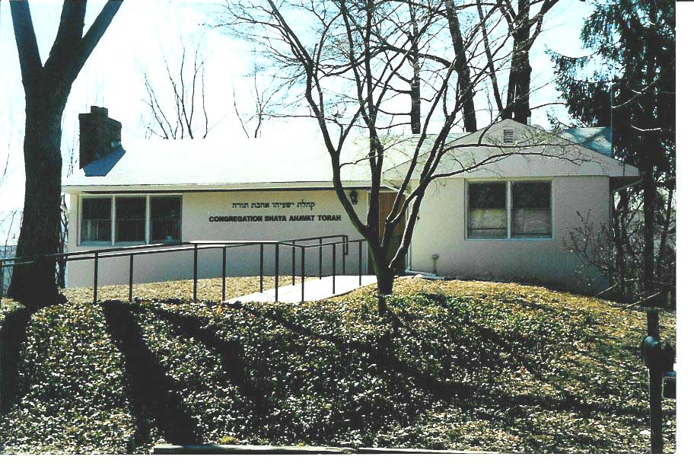

Shalom D. Lubin, Rabbi Naomi Rotter, President


Ha Etone
The Newsletter of Congregation Shaya Ahavat Torah

Parsippany, NJ Spring-Summer 5780
973-335-3636 Apr., 2020 – Sept., 2020

http://www.shayaahavattorah.org

Pesach Message 5780

What a challenging and unusual time we find ourselves in! After a month of social distancing and isolating ourselves, we are now celebrating the holidays of Pesach-the Festival of Freedom.
I think many of us celebrated the Seder every year by looking in a so-called rear view mirror of life.
Our ancestors were slaves in Egypt, God freed them and gave them the Torah, and eventually built a Temple in Jerusalem, the fullest expression of freedom.
We look back and remember the stories of our own family; how they came from the persecuted and oppressed countries of Europe to this country to find greater opportunity, and to live their lives openly as Jews.
This year, we do not need to look at the past at all.
We are suffering, we are isolated, we feel scared and alone, and what we yearn for more than anything is freedom to go out and live the lives we are used to living! We yearn to go back to Shul, to daven, to study, to celebrate Kiddush and enjoy holidays together.
We say in the Hagada: Hashata Avdin, L’shana Habaah Bnei Chorin- This year we are slaves, next year may we be free.
May it happen sooner than we anticipate!
Aharona and I wish you a Kosher a Joyous Pesach.

Rabbi Lubin



The Increased Importance of Modeh Ani
Each day, when we wake up in the morning, we begin the day with the Modeh Ani prayer, a prayer of gratitude to Hashem for restoring our faculties. I often precede it with the children’s version sung to the tune of ‘You are my Sunshine.” In the morning when I wake up, I open my eyes and I say: Thank you Hashem for my nishomah and giving me another day. It is simple and it captures it all: thank you for giving me another day. In these tumultuous times of Covid 19, another day is something we should not take for granted. The simple act of gratitude to Hashem starts our day on a positive note, and we all need to accentuate the positive.
The exercise of gratitude has positive effects on us and those around us. According to some research studies, gratitude leads to our being more helpful and more hopeful, more forgiving and more caring and less depressed and resentful. And gratitude can foster more positive feeling in others. That is something we as Jews should know when we practice HaKarat HaTov, the act of expressing gratitude. It all begins with faith. We practice gratitude in our prayers daily and in our psalms. We say in Shemoneh Esrei: Modim anachnu lach. “ We gratefully thank you. And in Psalm 116, King David writes. “ How can I repay God for all His kindness to me?” Every Shabbos in the great psalm 136 we say, “Hodu, HaShem Ki Tov. Give thanks to Hashem for He is good”
So we have the words for thanking HaShem, we need to be sure in these trying times that we mean the words. Yes, we are stressed just by the news alone. And it is not just the news; it is the social distancing and the upsetting feelings of having our beloved Pesach festival traditions upended. But we still have Pesach. No one is taking Pesach away. And we have food and food for Pesach. (If anyone has a problem obtaining food, please contact Rabbi Lubin or me.) And we do have our family and community, just not face to face at this time. We have new ways of connecting and some of these new ways I hope continue after the virus abates. One more reason for our gratitude is the beautiful renovated basement of the shul into a proper social hall. We have received the certificate of occupancy from the town signaling we have passed all required inspections. If you have not yet seen the renovations, you will be astonished at the outcome. For this, we need to shout a loud thank you to Rabbi Lubin who has been the inspiration and project manager for all of it. This would never have happened without his vision, his motivation, his planning and his execution. We are so fortunate to have him as our Rabbi. As always, please remember the custom of Maot Chittim, of communities providing for those in need during Pesach. Donations can be given to Rabbi Lubin or mailed to Bob Herman and marked for Maot Chittim.
On behalf of your board and personally, a ziesen Pesach.

Naomi

**********************************************************************************************

Leaves for the Tree of Life for Building Fund donations are available. Contact Naomi Rotter at 973-299-6277 for more information.

**********************************************************************************************





- Mazel tov to Mimi Gold on the birth of her granddaughter, Charley Rae Vergara, on Sept.11. Mazel tov also to parents, Erica and Anthony Vergara. Charley is named for her great grandmother, Rhoda Gold.
- Mazel tov to Michael and Amanda Lowenstein on the birth of their son, Ryan Rami, on Jan. 31.
- Mazel tov to Ed and Gilda Norin on the Bat Mitzvah of their granddaughter, Chedva Rachel Jackson.

**********************************************************************************************

Linda Golovin
Rosemarie Alroy
Yair Alroy
Ken Cohen

************************************************************************************
A way to memorialize those dear departed in perpetuity is to provide a memorial plaque on the Yahrzeit Board in the Synagogue. Kaddish is recited at the time of Yahrzeit and names are automatically included in prayers during Yizkor. For information about the purchase of a plaque, contact Dr. Louis Goodman at 973-263-3021.

**************************************************************************************************

Yahrzeits for Spring-Summer

     
Benjamin Levitt  Gustave Strow  Solomon Goodman | 7 Nisan  7Nisan  8 Nisan
Max G. Peres | 8 Nisan
Samuel Feather | 8 Nisan
Arlene Cohen | 9 Nisan
Molly Baron | 11 Nisan
Sylvia Burman | 13 Nisan
Arnold Hilliard Netburn | 18 Nisan
Lillian Dembrofsky | 19 Nisan
Sydney Brothman | 20 Nisan
Morris Weiss | 24 Nisan
Milton Feldman | 27 Nisan
Mildred Braverman | 28 Nisan
Bernard Rutman | 30 Nisan
Lee Gotowner | 30 Nisan
Daniel Gotkis | 1 Iyar
Ephraim Rotter | 2 Iyar
Reba Goodman | 4 Iyar
Ida Goldberg | 8 Iyar
Stephen Gotkis | 9 Iyar
Benjamin Matthew Rosenberg | 9 Iyar
Mollie Fink | 9 Iyar
Joe Dembrofsky | 11 Iyar
Gustave David Suffin | 12 Iyar
Henry I. Zames | 14 Iyar
Nette Lovitt | 14 Iyar
Lauretta Druckman | 20 Iyar
David Zeitlin | 21 Iyar
Anna Gavrin | 21 Iyar
Marlene Feldman | 23 Iyar
Susan Goldberg | 26 Iyar
Abraham Pallas | 27 Iyar
David Yitzchak Cohen | 1 Sivan
Zohara Bohbot | 1 Sivan
Rose Samach | 2 Sivan
Chana Toledano | 2 Sivan
Leo Netburn | 2 Sivan
Martin Yazersky | 8 Sivan
George Rotter | 9 Sivan
Abraham Gotkis | 12 Sivan
Henry Burman | 13 Sivan
Eva Schwartz | 15 Sivan
Ruth Gotkis | 17 Sivan

Yahrzeits for Spring-Summer
(continued)

Jeanette Kaplan | 18 Sivan
Aron Ostro | 21 Sivan
Morris Genden | 26 Sivan
Joseph Hoch | 27 Sivan
Sidney Gotowner | 28 Sivan
Samuel Rotter | 3 Tamuz
Max Rosenberg | 3 Tamuz
Nathaniel Golovin | 5 Tamuz
Rabbi David Weiss | 5 Tamuz
Marshall Pallas | 6 Tamuz
Theresa Suffin | 8 Tamuz
Bertha Graw | 11 Tamuz
Sol Schwebel | 16 Tamuz
Sarah Weiss | 17 Tamuz
Dr. Alan Feldman | 18 Tamuz
Sylvia Bookbinder | 23 Tamuz

Hyman Fink | 2 Av
Mercedes Chocron | 3 Av
Betty Eagle | 3 Av
Moshe Pistiner | 4 Av
Bella “Belle” Netburn | 6 Av
Simon Bohbot | 7 Av
Morris Strow | 12 Av
Irma Dembroff | 16 Av
Ethel Chibnick | 24 Av
Julius Samach | 27 Av
Samuel Dembroff | 28 Av
Julian Weidler | 29 Av
Anna K. Zames | 3 Elul
Anna Pallas | 4 Elul
Ruth Hoch | 5 Elul
Hilda E. Levitt | 9 Elul
Cantor David Speiser | 10 Elul
Ida Druckman | 15 Elul
Dora Greenspan | 16 Elul
Joseph Jacobs | 18 Elul
Solomon Brown | 19 Elul
Benjamin Tyzler | 20 Elul
Helen Rich | 20 Elul
Jean Feather | 22 Elul
Julius Eagle | 26 Elul
Eileen Goodman | 29 Elul

             
     

Luach Spring Summer 5780

Date | Parsha | Candle Lighting | Friday Mincha | Shabbos Mincha | Shabbos Ends
4/17-18 | Shemini | 7:22 PM | 7:25 PM | 7:00 PM | 8:24 PM
4/24-25 | Tazria Metzorah | 7:29 PM | 7:30 PM | 7:10 PM | 8:32 PM
5/1-2 | Achare Kedoshim | 7:37 PM | 7:40 PM | 7:15 PM | 8:41 PM
5/8-9 | Emor | 7:44 PM | 7:45 PM | 7:25 PM | 8:49 PM
5/15-16 | Behar Bechukosai | 7:51 PM | 7:51 PM | 7:30 PM | 8:57 PM
5/22-23 | Bamidbar | 7:57 PM | 8:00 PM | 7:35 PM | 9:05 PM
6/5-6 | Naso | 8:08 PM | 8:10 PM | 7:45 PM | 9:17 PM
6/12-13 | Behaloscha | 8:12 PM | 8:15 PM | 7:50 PM | 9:21 PM
6/19-20 | Shelach | 8:15 PM | 8:15 PM | 7:55 PM | 9:24 PM
6/26-27 | Korach | 8:16PM | 8:20 PM | 7:55 PM | 9:24 PM
7/3-4 | Chukas Balak | 8:15 PM | 8:15 PM | 7:55 PM | 9:23 PM
7/10-11 | Pinchas | 8:12 PM | 8:15 PM | 7:55 PM | 9:19 PM
7/17-18 | Matos-Masei | 8:08 PM | 8:10 PM | 7:50 PM | 9:14 PM
7/24-25 | Devarim | 8:03 PM | 8:05 PM | 7:40 PM | 9:07 PM
7/31-8/1 | Vaeschanan | 7:56 PM | 8:00 PM | 7:35 PM | 8:59 PM
8/7-8 | Ekev | 7:48 PM | 7:50 PM | 7:25 PM | 8:50 PM
8/14-15 | Re’ei | 7:39 PM | 7:40 PM | 7:20 PM | 8:39 PM
8/21-22 | Shoftim | 7:28 PM | 7:30 PM | 7:10 PM | 8:28 PM
8/28-29 | Ki Seitzei | 7:18 PM | 7:20 PM | 7:00 PM | 8:16 PM
9/4-5 | Ki Savo | 7:06 PM | 7:10 PM | 6:45 PM | 8:04 PM
9/11-12 | Nitzavm Vayelech | 6:55 PM | 7:00 PM | 6:35 PM | 7:52 PM

SPECIAL TIMES TO BE AWARE OF

PESACH SCHEDULE 5780

Wednesday April 8-Erev Pesach

Phone Siyum- 8 AM
Last Time To Eat Chametz – 10:25 AM
Burn Chametz by 11:43 AM

Make an Eruv Tavshilin!
Candle Lighting-7:12 PM

Thursday April 9-First Day Yom Tov

Shachris-9AM
Mincha –7:10 PM
Light Candles From Preexisting Flame – After 8:14 PM
Begin counting the Omer!!!

Friday April 10 – Second Day Yom Tov
Shacharis - 9:00 AM
Light Candles From Preexisting Flame – 7:15 PM
Mincha – 7:10 PM

April 11 Shabbos Chol Hamoed
Shachris- 9 AM
Shir Hashirim- 10:00 AM
Mincha – 6:55 PM
Shabbos ends-8:16 PM

Tuesday April 14th Erev Y”T
Light Candles –7:19 PM

Wednesday April 15– Shevii Shel Pesach
Shacharis – 9:00 AM
Mincha – 7:00 PM
Light Candles From Preexisting Flame – After 8:21 PM

Thursday April 16– Acharon Shel Pesach
Shacharis – 9:00 AM
Yizkor-10:30 AM
Mincha followed by Moshiach Seudah– 7:00 PM
Yom Tov Ends – 8:22 PM

Please do not use any of your Chametz items until after 9:15 PM

Friday and Shabbos April 24 and 25 -Rosh Chodesh Iyar

Friday May 8-Pesach Sheni

Tuesday May 12-Lag Baomer

Sunday May 24-Rosh Chodesh Sivan

Thursday May 28-Erev Shavuos

Make an Eruv Tavshilin!
Candle Lighting 8:03 PM
Mincha 8:05 PM

Friday May 29-First day of Shavuos
Shachris- 9 AM
Mincha –8:00 PM
Candle Lighting (From existing flame)-8:03 PM

Shabbos May 30-2nd day of Shavuos
Shachris-9:00AM
Megilas Rus/Yizkor 10:00 AM
Mincha 7:40 PM
Yom Tov Ends 9:11 PM

Monday & Tuesday June 22, 23 Rosh Chodesh Tamuz

Thursday, July 9- Fast 17th of Tammuz- Begins the 3 Weeks

Fast Begins: 3:48 AM
Fast Ends: 9:04 PM

Wed. July 22- Rosh Chodesh Av

Beginning of the 9 Days

Wed. Eve. And Thurs. July 29-30
Tisha B’Av

Fast Begins: 8:16 PM
Fast Ends: 8:46 PM

Thurs. and Fri. August 20, 21
Rosh Chodesh Elul


ShopRite of Parsippany

808 Route 46, Parsippany NJ
(973) 335-2625

Don’t tell me that you’re Still Not Using Shop-Rite Gift Cards or Pathmark Scrip.

Tell Lou Goodman (973- 263-3021) and get that gift card or scrip. When you shop with gift cards or scrip, Shop-Rite gives 5% of your total to the synagogue. It’s easy, it’s painless, it’s a miracle. The gift cards are so easy to use. Get with the program. Every time you use cash, the shul loses. Make the shul a winner

Imagine your business card here. Ha Etone now will publish business cards each edition. HaEtone has a circulation of over 150 interested readers covering Northern New Jersey, Central New Jersey, New York and Philadelphia.

Narrow Cast Your Business to our involved readership.

Contact Naomi at nbrotter@optonline.net for more information.

Congregation Shaya Ahavat Torah
113 Hawkins Ave. Parsippany, NJ 07054
973-335-3636.
http://www.shayaahavattorah.org/

Shalom D. Lubin Rabbi
Naomi Rotter President
Louis Goodman Rosh Gabbai
Bob Herman Treasurer
Linda Golovin Secretary & Newsletter Editor

